Download UIPath from

<https://www.uipath.com/developers/enterprise-edition-download>

You will receive and email and then you will be able to download the file that is needed to change the extension to .exe

**Prerequisites**

Install IIS 7.5 or higher

<https://www.microsoft.com/en-us/download/details.aspx?id=48264> (for IIS 10)

Check your machine has Remote Desktop Users local group, in Computer Management.

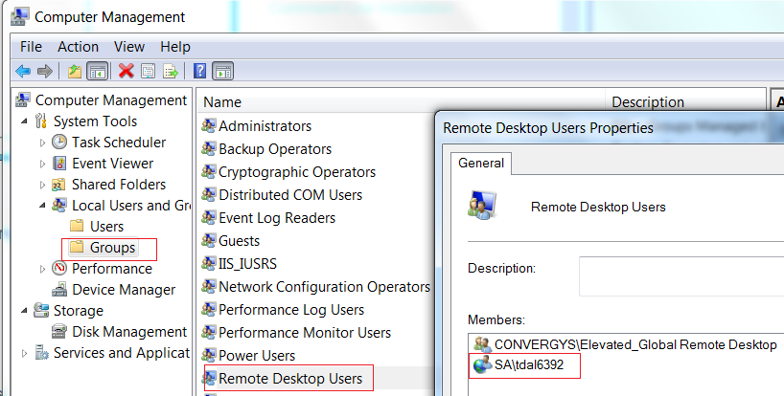

In this case In the Group (Remote Desktop Users) it is my account, SA\tdal6392

The Group must have these rights (I THINK IT IS ALREAY, BUT JUST IN CASE)

* Access this computer from the network
* Allow log on locally
* Allow log on throguht Remote Desktop Service

For this check the rights of the group

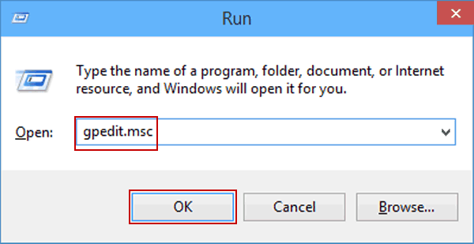

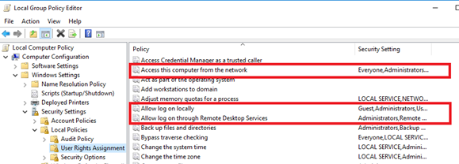

# Windows Installation

There are two installers which can help you install Robot on your computer: **UiPathPlatformInstaller.exe** and **UiPathStudio.msi**. The only difference between the two is that the UiPathPlatformInstaller.exe setup can also help you install Orchestrator.

By default, Robots are installed at the following location - C:\Program Files (x86)\UiPath\Studio.

The .exe doesn’t install the robot, only the msi

[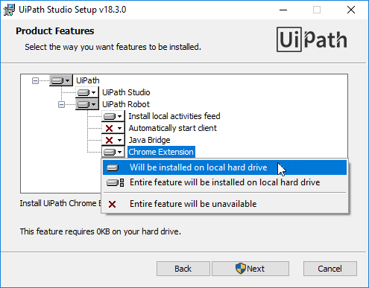](https://files.readme.io/83f0e0d-installing_studio_window.png)

After reading and accepting the terms of the License Agreement, the following **Advanced** options are available:

* **UiPath Studio** - Installs Studio. This option is enabled by default.
* **UiPath Robot** - Installs the Robot on the local hard drive, as a [Robot Windows service](https://robot.uipath.com/docs/introduction). This option is installed by default and it cannot be disabled.

### Important!

Installing the Robot in user mode is possible only through [command line parameters](https://studio.uipath.com/v2018.3/docs/msi-command-line-parameters).

* **Install local activities feed** - C:\Program Files (x86)\UiPath\Studio\Packages it is useful if you do not intend to connect your Robot to Orchestrator, or you want to have a better control of the activities used in an automation project.
* **Automatically start client** - Starts the Robot tray at Windows startup. This option is disabled by default.
* **Java Bridge** - This option installs the Java Bridge only in the system drive Java folders.
* **Chrome Extension** - For automating processes in Chrome. This option is enabled by default.